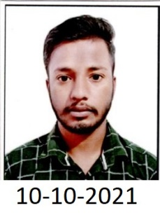

**Name :- Rajat Kumar**

**Address :- Vpo Dukheri,Ambala Cantt**

**Pincode :- 133004**

**Contact No. :- 9817623758**

**Email ID :-** [**rajatjawa123@gmail.com**](mailto:rajatjawa123@gmail.com)

**EDUCATIONAL QUALIFICATIONS**

|  |  |  |  |  |
| --- | --- | --- | --- | --- |
| **Year** | **Degree** | **School/Institute** | **Board/University** | **%age /CGPA** |
| March-2014 | Matric | Govt. Sr. Sec. School, Dukheri | HBSE | 63.2% |
| July-2021 | ITI | Industrial Training Institute,Barara(Holi) | NCVT | 75.5% |

**Certification**

* **6 Months BASIC & D.T.P. Computer Course from COMPUTER HOUSE EDUCATION**

**(Nanhera Road,Ambala Cantt).**

**Work Experience / Volunteer Activities**

|  |  |  |
| --- | --- | --- |
| Work Experience / Volunteer Activities | | |
| Name of the organization | : | Common Services Centers (CSC) |
| Job Responsibilities | : | Village Level Entrepreneurs (VLE’s) |
| Work Duration | : | 2019 -2021 |

**INTERPERSONAL SKILLS**

* Ability to listen someone and then giving ideas to him/her.
* Ability to communicate with people in a confident way.
* Ability to handle the problems with positive attitude and in less time.

**HOBBIES/INTERESTS**

* Listening music.
* Playing Cricket.
* To watch Cricket.

**PERSONAL INFORMATION**

**Father name :** Sushil Kumar

**Date of Birth** : 22/04/1999

**Gender :** Male

**Marital Status** : Unmarried

**Language Proficiency**: English, Hindi

**DECLARATION**

*I do hereby declare that the above information is true to the best of my knowledge****.***

*(Signature)*

**Name: Rajat Kumar**

**Place: Vpo Dukheri,Ambala Cantt**